# 7-2 Project Two

## About the Project/Rescue WebApp

This project is a MongoDB web application dashboard. This includes a python module that enables CRUD database functionality and a frontend dashboard using the Dash framework. The intended goal was to develop a web-application, connecting the client-side UI to the backend MongoDB database. The Animal Rescue Company, Grazioso Salvare, wants to interact with and visualize data from animal shelters.

## Motivation*.*

The motivation behind this project is to develop a full stack web application for the project— with the goal of creating reusable and adaptable code between the client and server. CRUD functionality is universal in databases, and implementing this in the glue-level middleware allows the backend to interface with the client-side dashboard. On the other hand, updating these modules can smoothly facilitate any changes to database implementation with the base-level backend. From backend to frontend, the project uses MongoDB, Python, and Dash to implement the MVC design pattern.

## Getting Started

To get a local copy up and running, follow these simple example steps.

* Use the mongoimport tool to import the aac outcomes dataset into MongoDB.

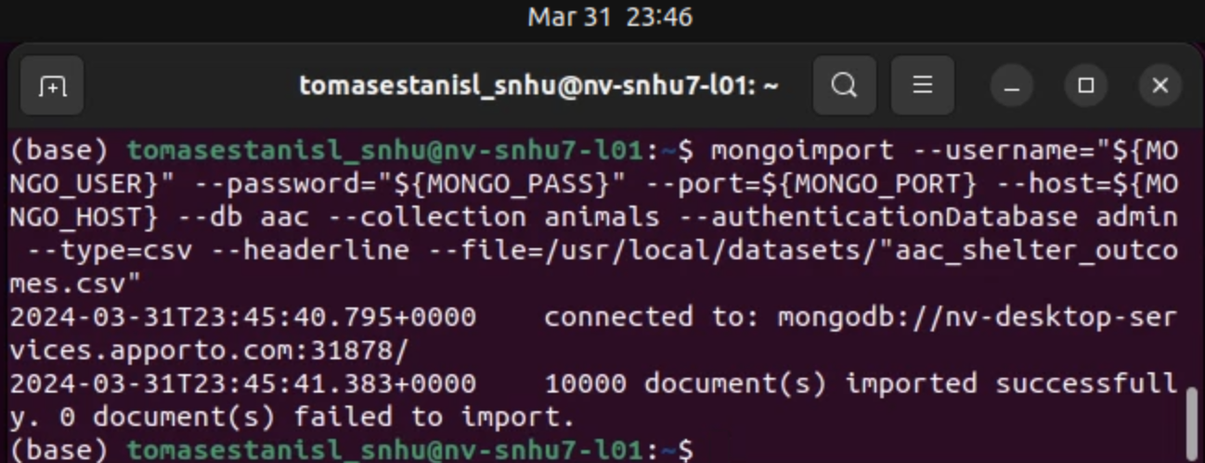

* Switch to the admin database to create a new user and password to use with the aac database. Use these new credentials— USER, PASS— when instantiating the AnimalShelter Service.

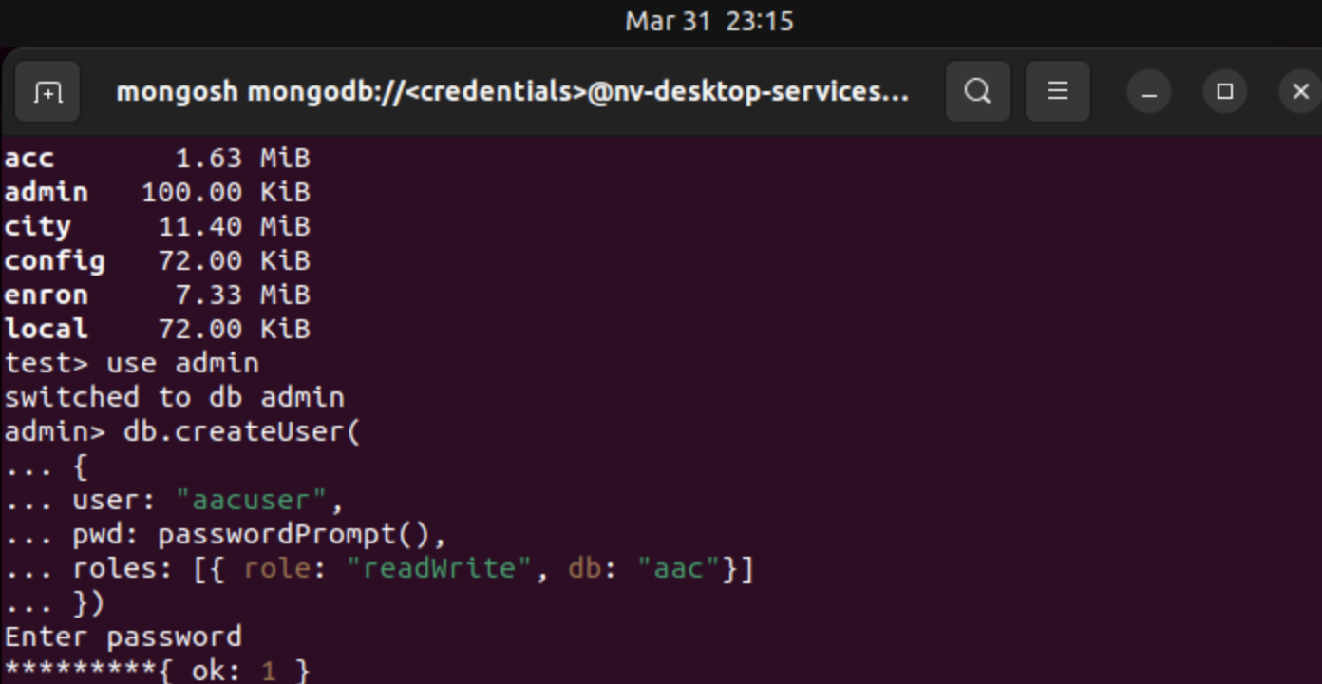

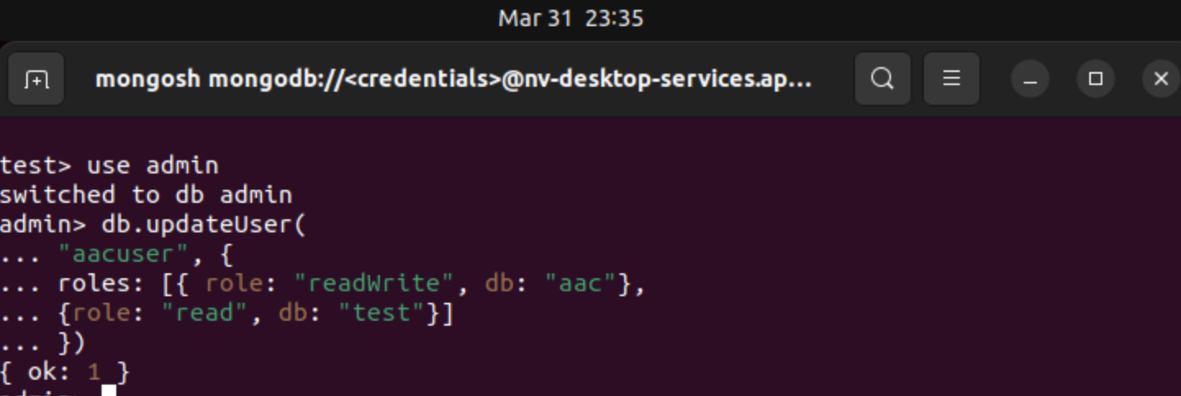

* Verify the login process by setting the MONGO-USER/PASS and checking the connection status.

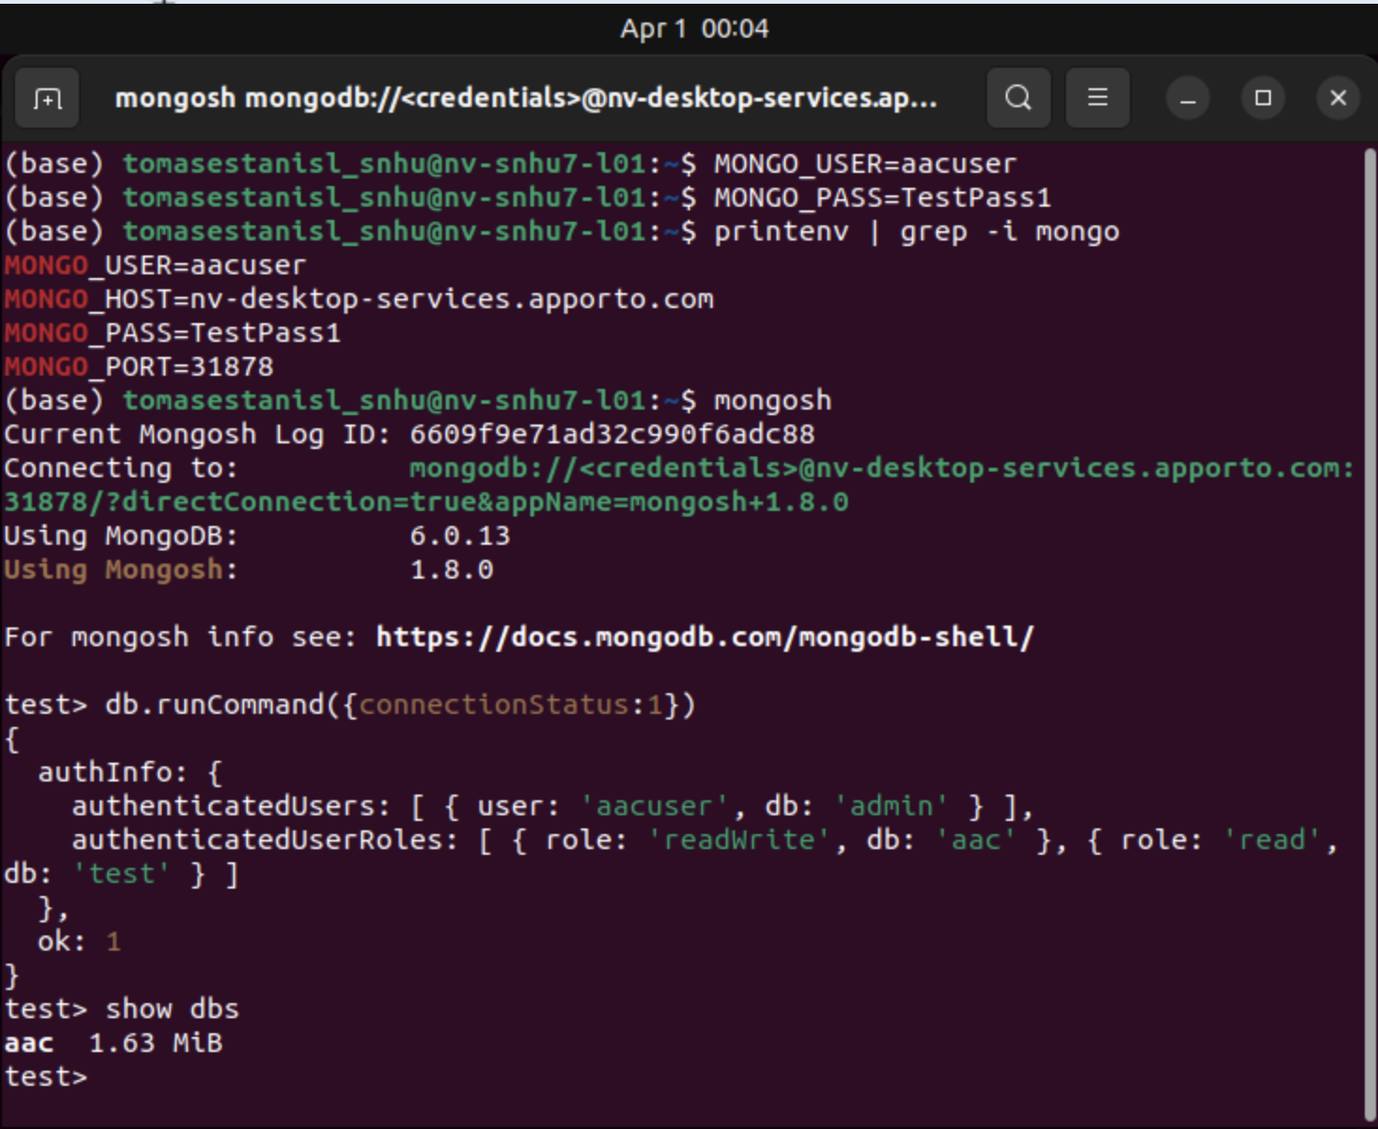

* The skeleton of the CRUD service was provided, including the __init__ and create method. Set up guides and example code for PyMongo can be found online: [*MongoDB CRUD using Python: A Step-by-Step Guide*](https://medium.com/@hemant.ramphul/mongodb-crud-using-python-a-step-by-step-guide-91f4f6750de8)*,* [*Get Started with MongoDB CRUD Operations in Python*](https://hevodata.com/learn/mongodb-crud-operations-in-python/)
* I referenced [*MongoDB Docs*](https://www.mongodb.com/docs/manual/crud/)*,* to get documentation regarding the various operations I needed to create. The main challenge was understanding the parameters for each method, as well as the return data types. Verifying these details is necessary to avoid type errors and ensure that each CRUD operation is properly implemented. This also helps when running tests.
* Create the Python CRUD module in an editor.

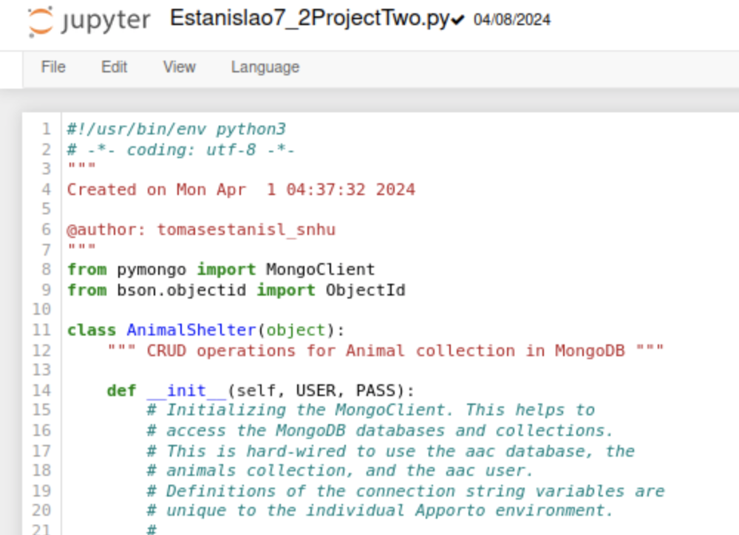

* Create the frontend python file that imports the Dash framework, Pandas library, and CRUD python module in Jupyter Notebook.

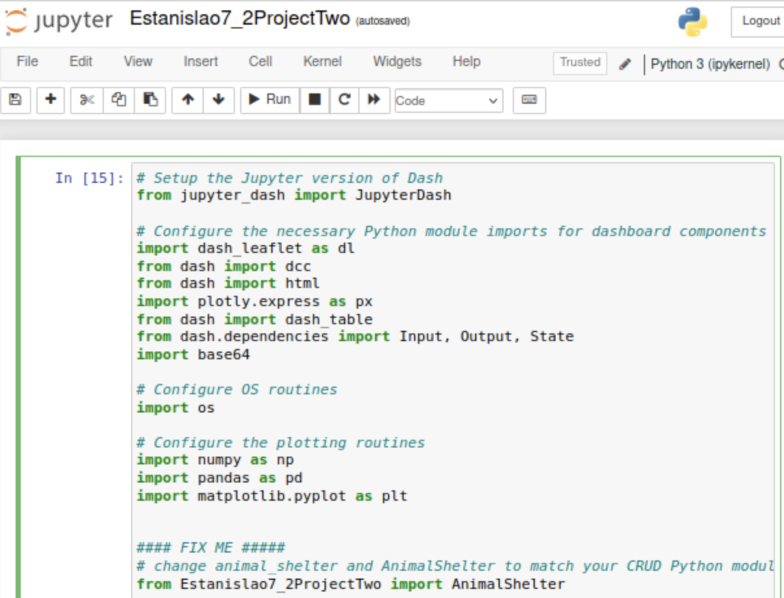

* The main challenge was understanding the dash framework, and how python interacts with the server. I am familiar with a RESTful API webservice with endpoints and requests, but I needed to understand how dash uses callbacks to listen to the frontend. Resources such as Medium articles were very useful to understanding [JupyterDash](https://medium.com/plotly/introducing-jupyterdash-811f1f57c02e) and [Pandas](https://medium.com/@nutanbhogendrasharma/working-with-mongodb-python-using-pymongo-and-pandas-f4ad5b581b35). Google, Stack overflow, and AI were useful for diagnosing error messages and narrowing down where they were coming from.

## Installation

The operating system used is Linux, and the following are tools needed to use the project:

[Python](https://www.geeksforgeeks.org/how-to-install-python-on-linux/), [MongoDB](https://www.mongodb.com/docs/manual/administration/install-on-linux/), [Pandas](https://pandas.pydata.org/docs/user_guide/10min.html), [Dash](https://github.com/plotly/jupyter-dash/blob/master/notebooks/getting_started.ipynb), [Jupyter Notebook](https://jupyter.org/install), and an IDE/Editor. The python module uses [MongoClient](https://pymongo.readthedocs.io/en/stable/tutorial.html) from pymongo and ObjectId from bson.objectid. The first is a python driver to set up a representation of a MongoDB cluster. The second is a tool to work with MongoDB objectId’s. PyMongo is easy and intuitive, with compatibility for dictionaries and lists. This is convenient for a model component— handling the business logic with a MongoDB database through python. Python and Pandas is part of the controller component that receives input from the Dash view component. The Dash app uses callbacks to listen for changes from frontend widgets, like radio buttons, selectable data rows, and interactive graphs. Dash uses html which is basic yet familiar for new learners. The controller uses pandas to interface with the model and store database data in a data frame. This data frame can then be used to create component tools for the view in the app layout and callbacks.

## Usage

The CRUD module is used to initiate the mongo client. It requires the controller to pass in user and password credentials when instantiating the AnimalShelter object. It contains create, read, update, and delete operations for full CRUD functionality. The controller imports the CRUD module, pandas library, and dash framework to tie the project together. The view is the implementation of the dash framework to create a visualization for the client in the browser.

### Code Example

* The service can be instantiated by calling AnimalShelter(USER, PASS) with arguments for the User MongoDB username and password.
* The service instance is queried using .read(query). This is used to manipulate the dataset according to user selected filters from the frontend.
* Filters include water, mountain, and disaster rescue categories— is a reset option to retrieve the full dataset.
  + The filters are implemented as radio items:

dcc.RadioItems( id='filter_type', options=[

{'label': 'Water Rescue', 'value': 'Wtr'}, #use values for filtering conditions

{'label': 'Mountain Rescue', 'value': 'Mtn'}, {'label': 'Disaster Rescue', 'value':

'Dst'}, {'label': 'Reset', 'value': 'Res'},],

value='Res' #default value should be full database reset

* + The controller listens for changes from the radio items and creates queries accordingly:

@app.callback(

[Output('datatable-id','data'),

Output('datatable-id', "selected_rows")], #added rows output to reset selected

[Input('filter_type', 'value')])

def update_dashboard(filter_type):

if filter_type == 'Wtr':

df = pd.DataFrame.from_records(db.read({ 'animal_type':'Dog', 'breed':{'$in':['Labrador Retriever Mix', 'Chesapeake

Bay Retriever', 'Newfoundland']},'sex_upon_outcome':'Intact Female', 'age_upon_outcome_in_weeks':{'$gt':26,'$lte':156}

# can combine queries with range {x1, x2} where x1<y<x2

}))

df.drop(columns=['_id'],inplace=True)

columns=[{'name': i, 'id': i, 'deletable': False, 'selectable': True} for i in df.columns]

data=df.to_dict('records')

selected_rows=[0]

return data, selected_rows

### There three further callbacks that listen for changes to the datatable: one to highlight the selected cell, one to create and modify the pie chart, and the last creates and modifies the geolocation chart with marker on the selected animal cell.

### Tests

The ipynb file is used to run the project and start the server. Tests can be run on the input and output with print statements within each function. An example is verifying the correct filter queries and printing to the console to confirm. Another test is to print the input arguments from each function to ensure that the controller is receiving the correct data from the client.

### Otherwise, testing can be done on the dash app within the browser to ensure functionality:

* + Viewing the data table and charts upon loading.
  + Confirming horizontal scrolling and pagination.
  + Ensuring changes from individual cell selection.
  + Verifying filter buttons and corresponding chart changes.
  + Clicking image logo hyperlink.

### Screenshots

Ipynb output on startup.

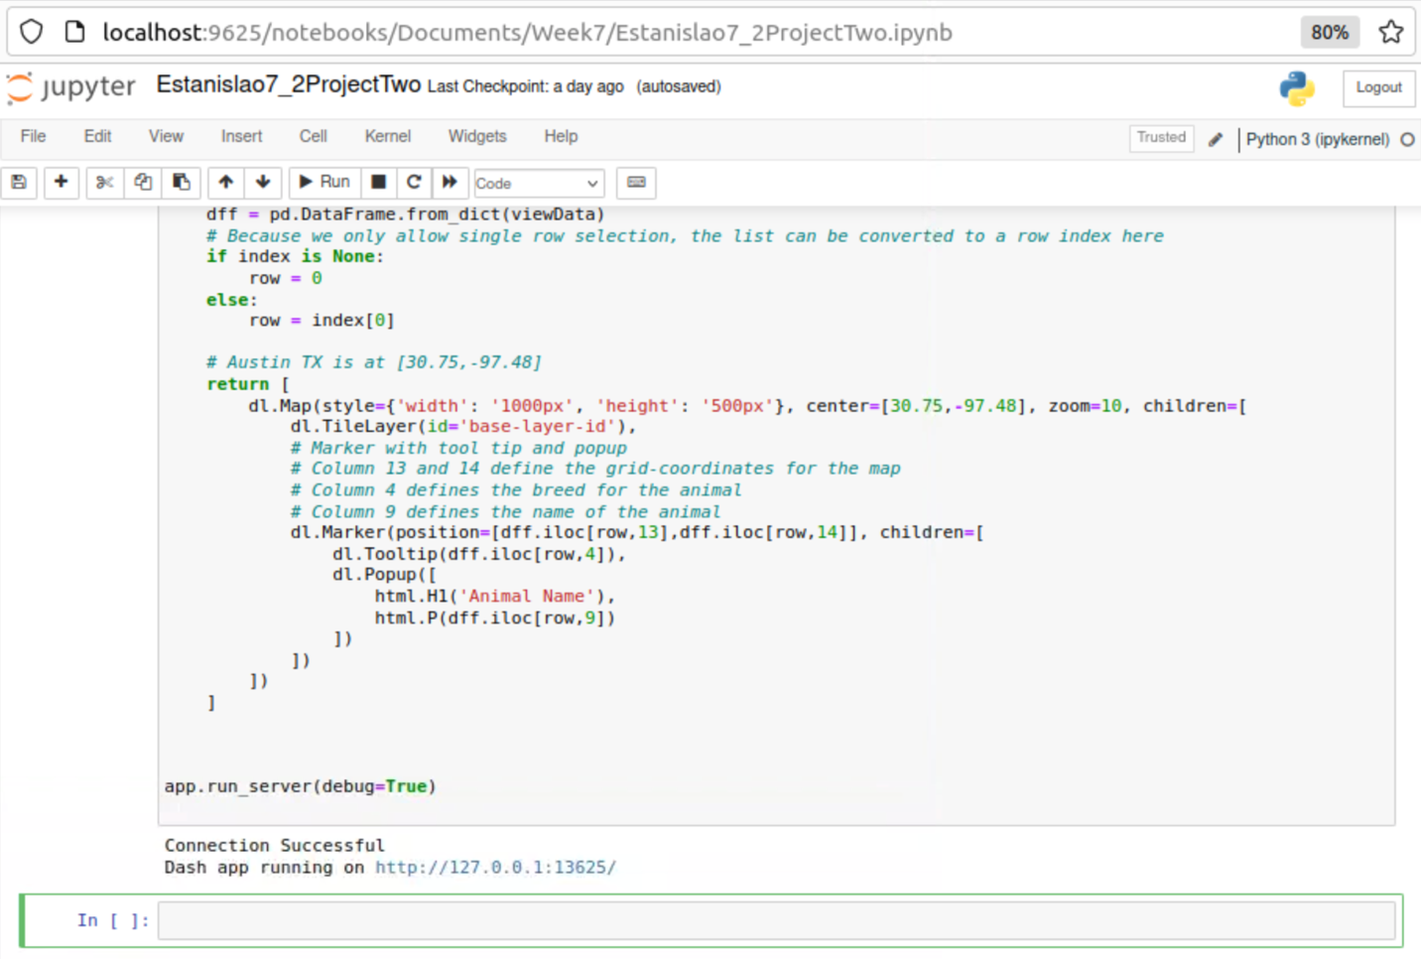

Viewing the data table and charts upon loading.

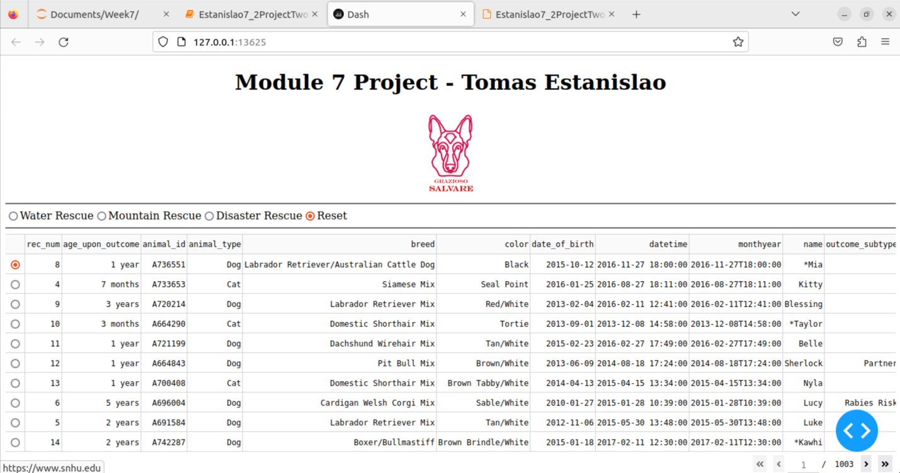

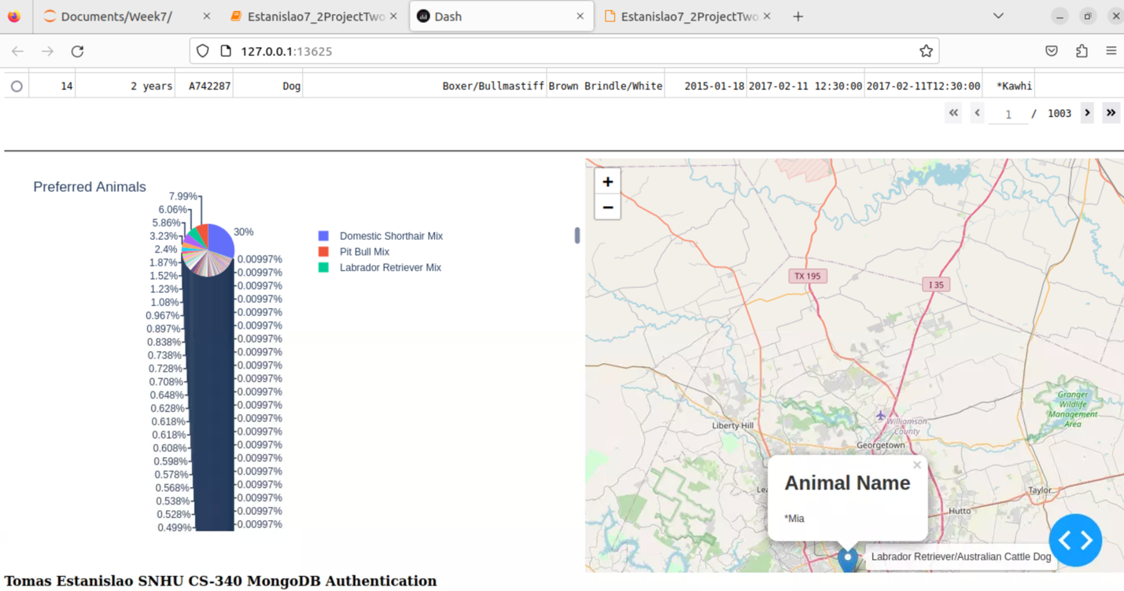

Confirming horizontal scrolling and pagination.

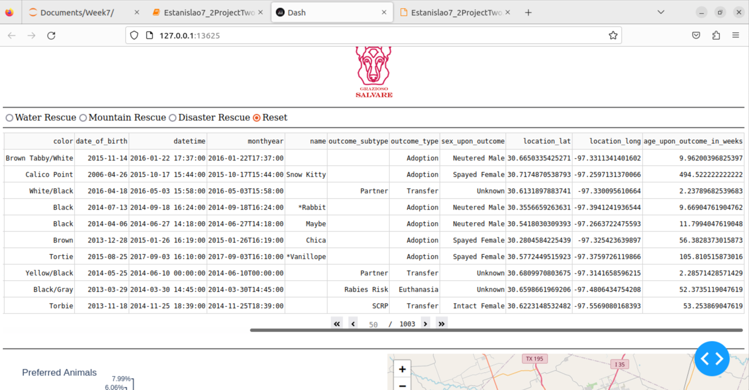

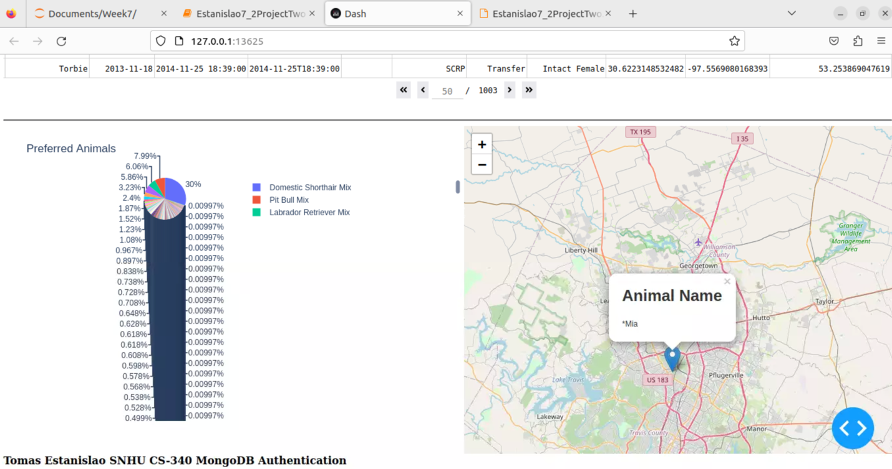

Ensuring changes from individual cell selection.

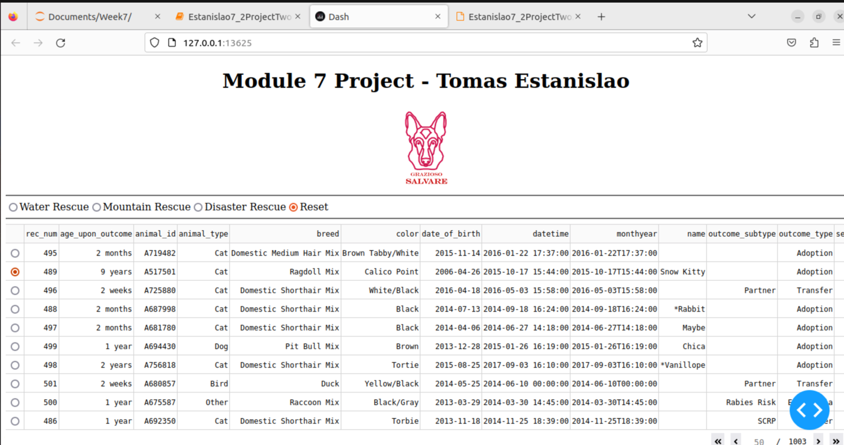

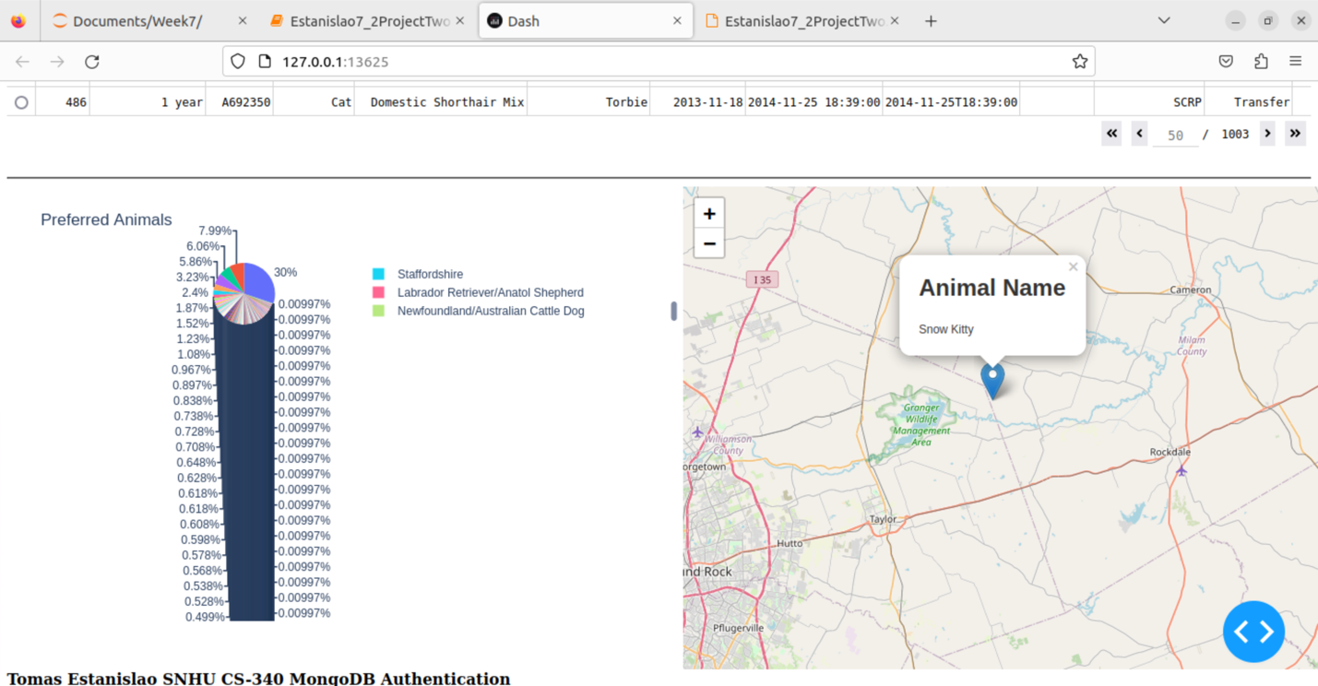

Verifying filter buttons and corresponding chart changes.

Water

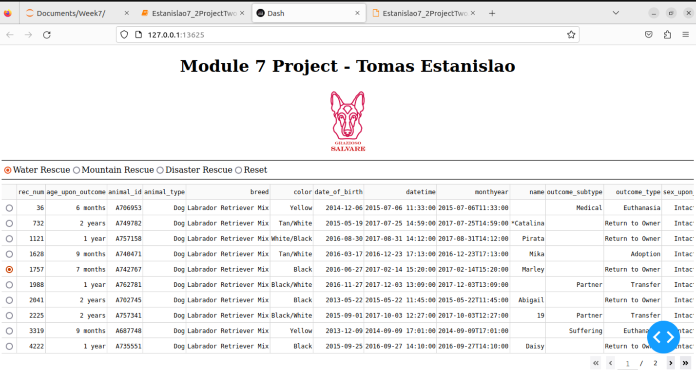

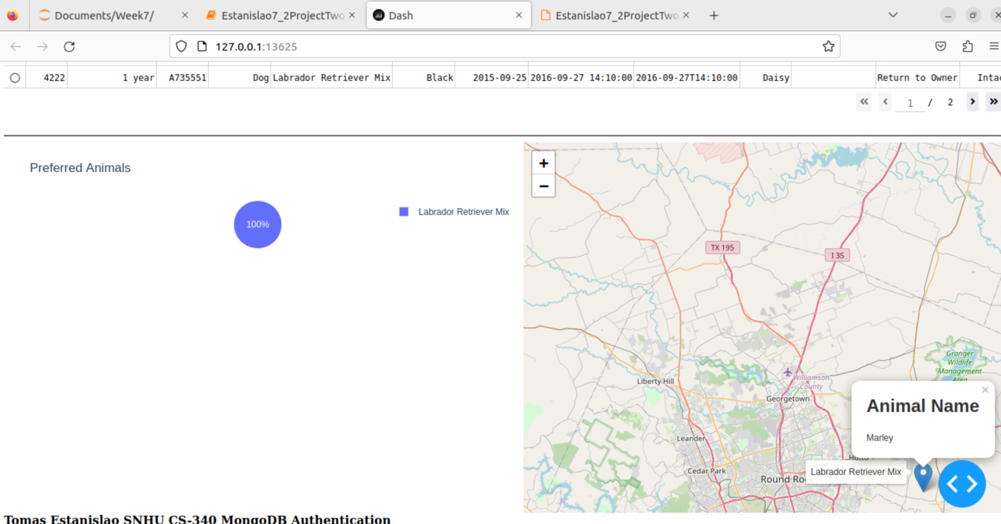

Mountain

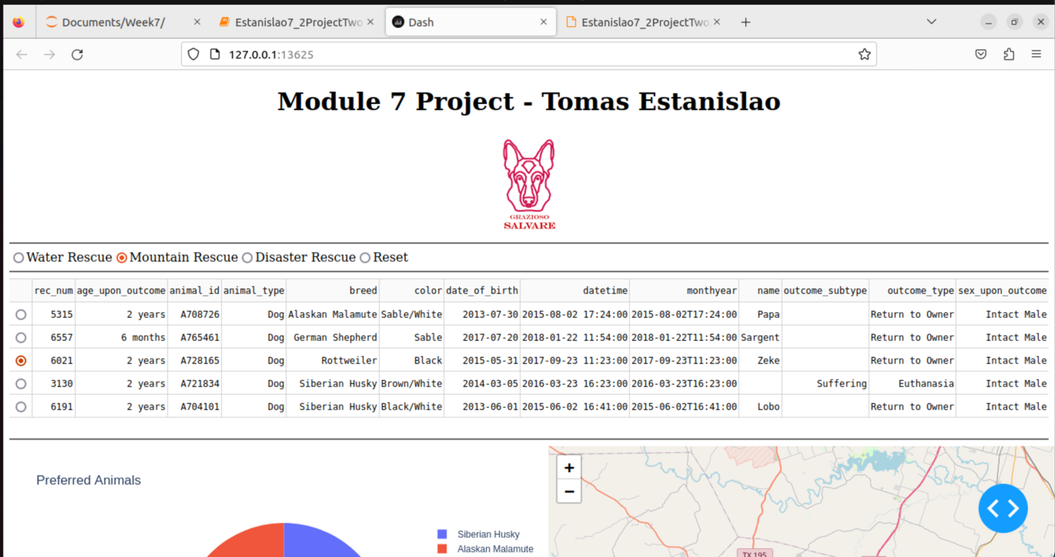

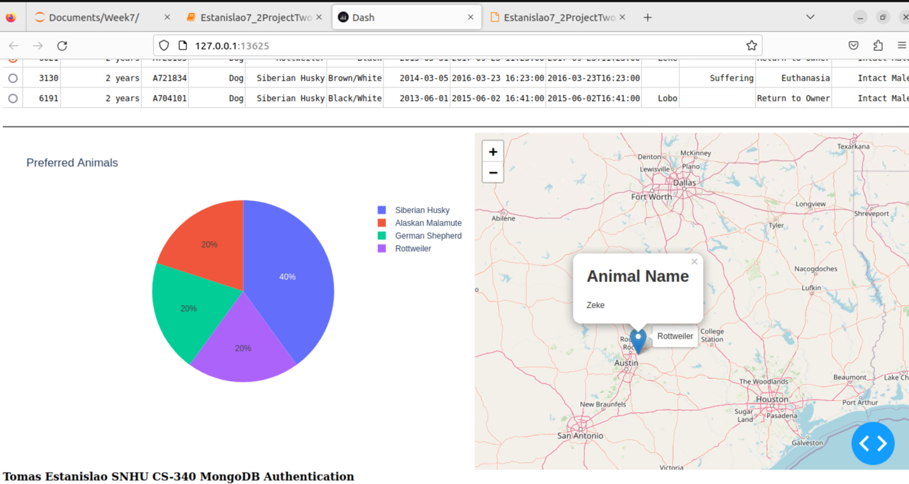

Disaster

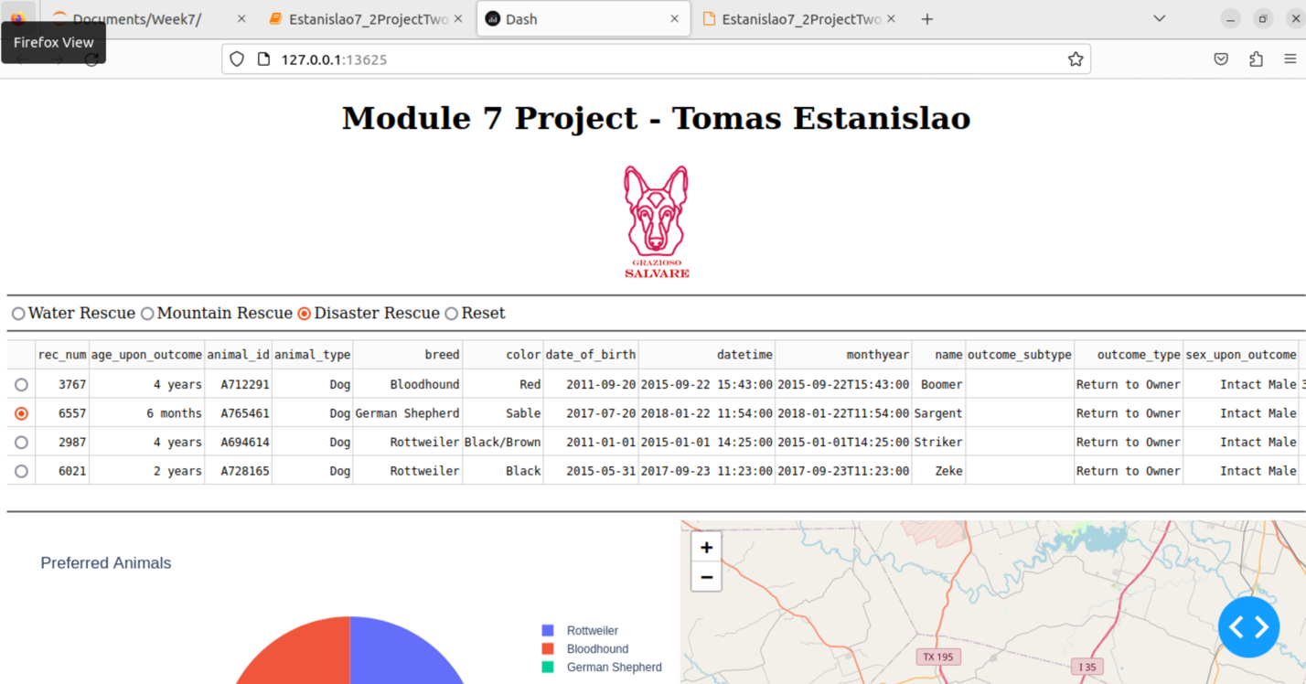

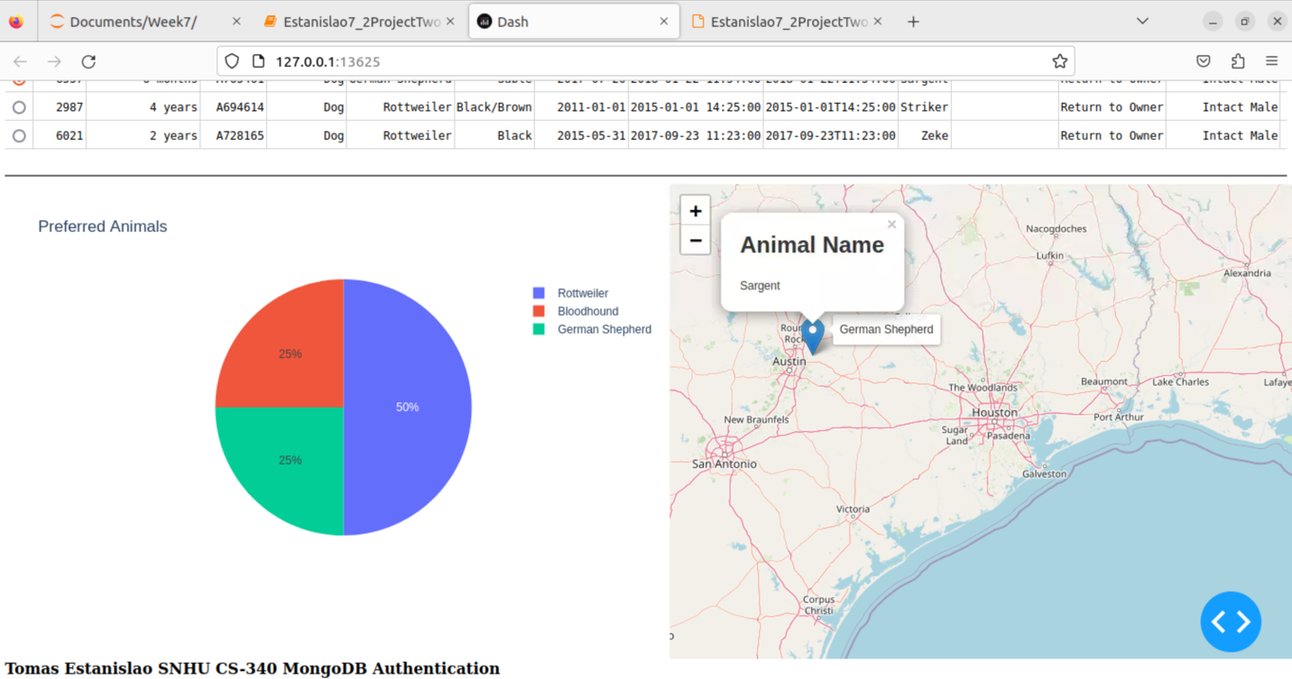

Reset

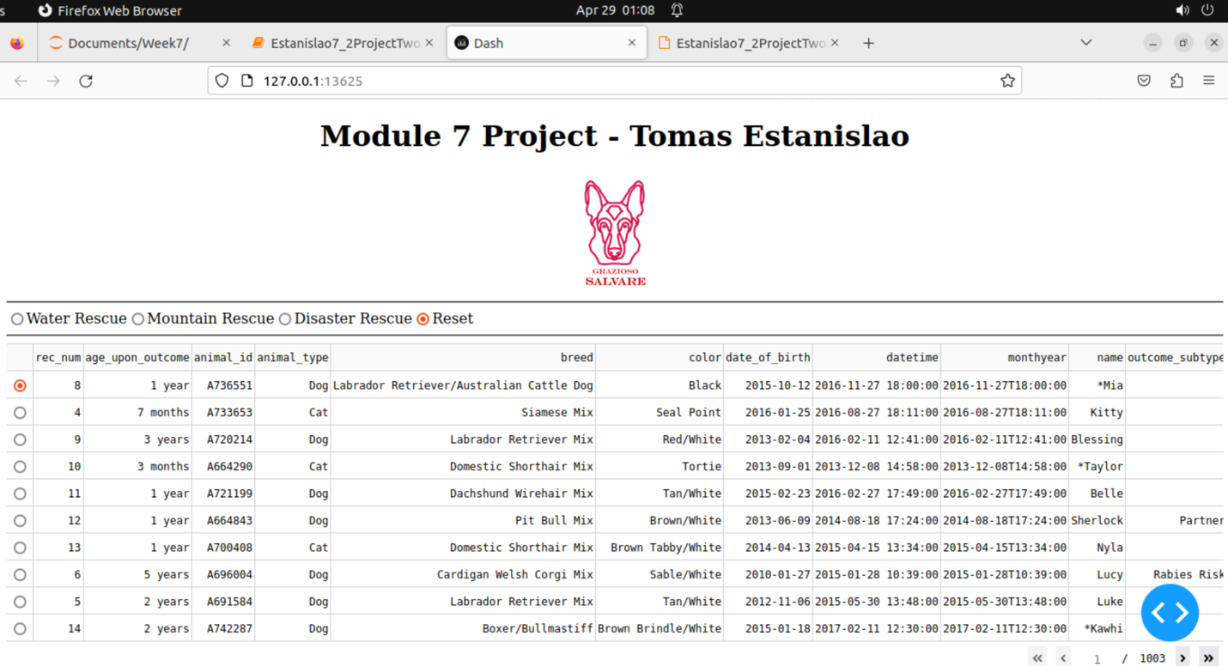

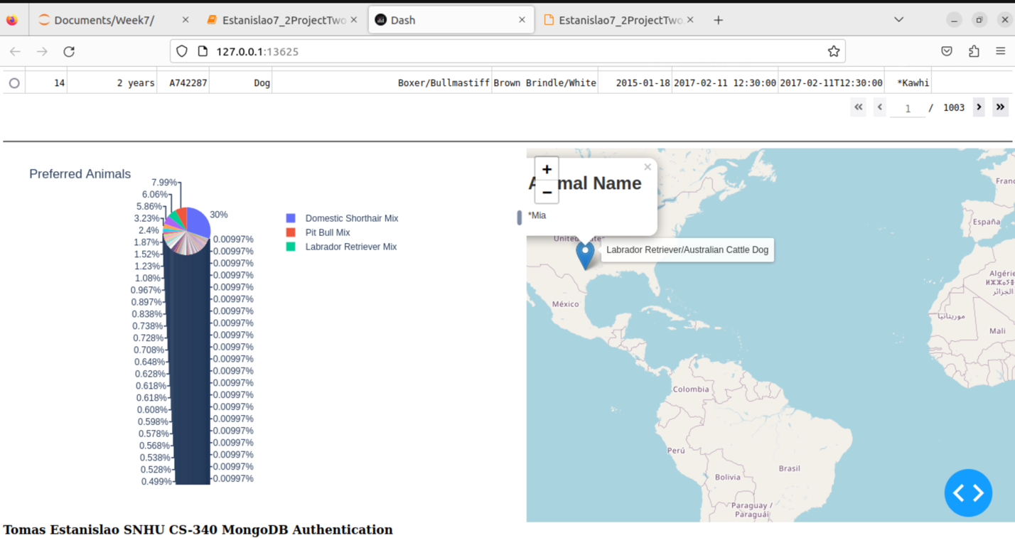

Clicking image logo hyperlink.

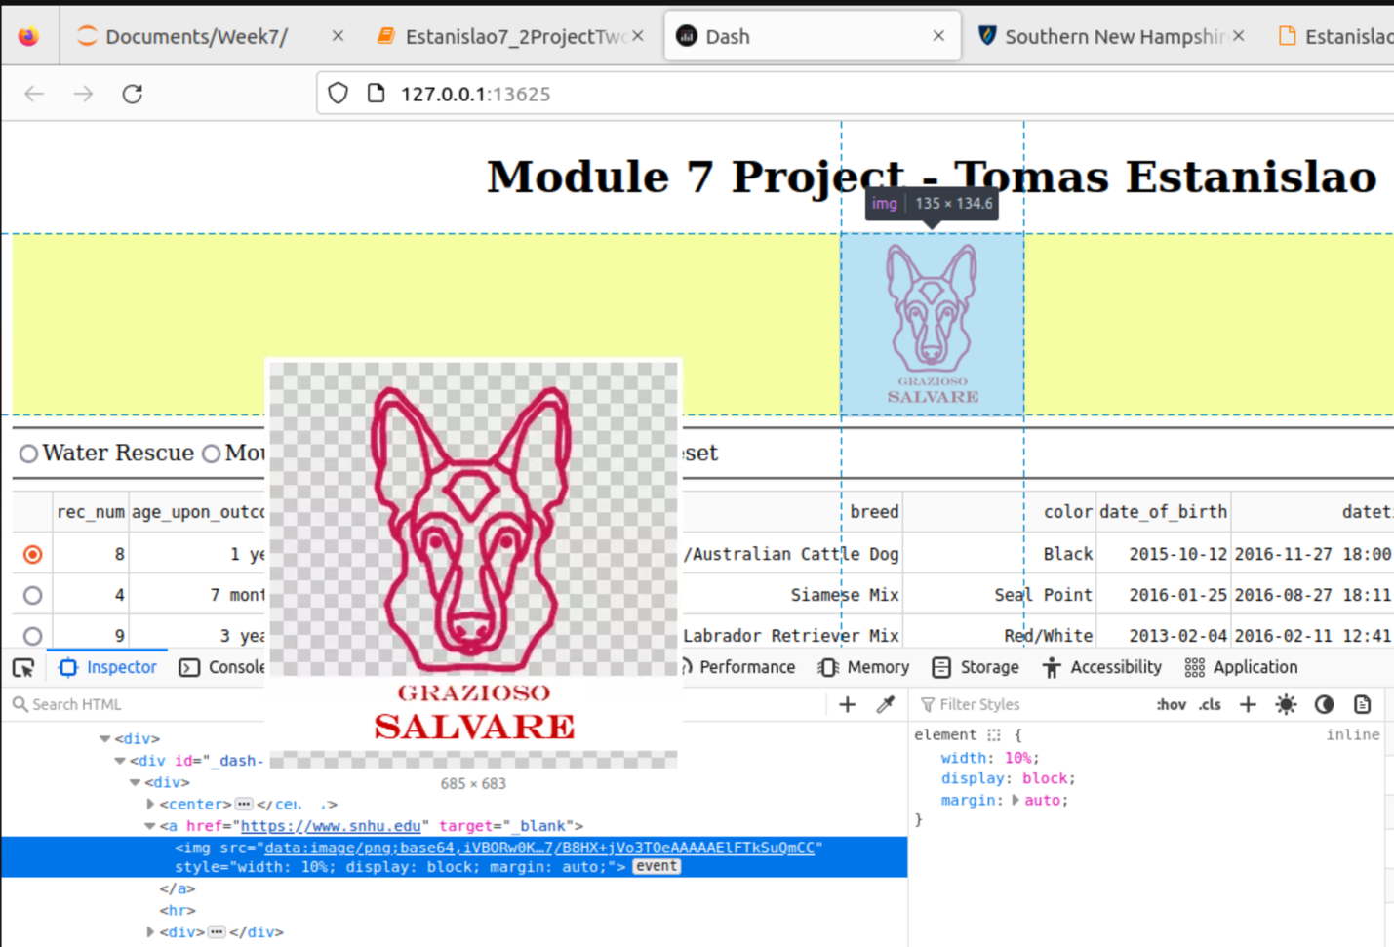

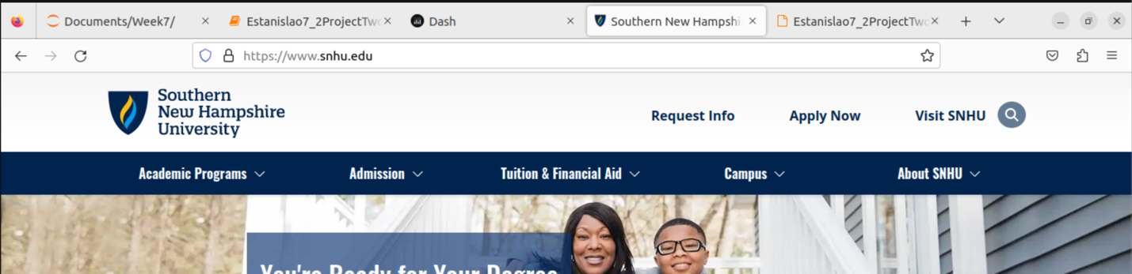

## Contact

Tomas Estanislao

Email: [tomas.estanislao@snhu.edu](mailto:tomas.estanislao@snhu.edu)